**1. WAQ to find top 5 highest paid employees.**

select first_name, salary from(

select first_name, salary

from hr.employees order by salary desc

) where rownum <= 5;

Or

select * from(

select first_name, salary

from hr.employees order by salary desc

) where rownum <= 5;

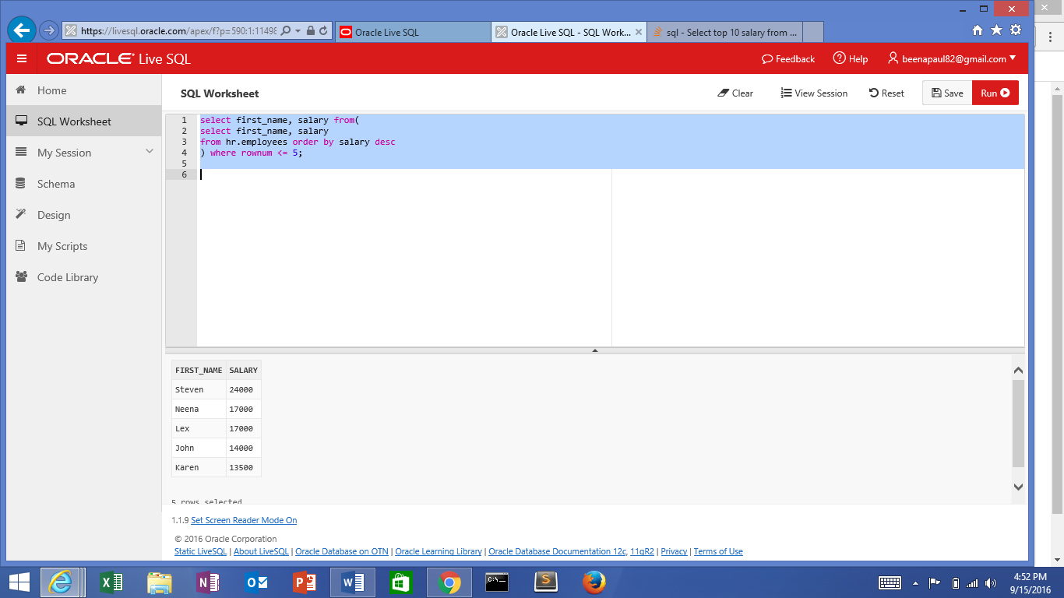

2.WAQ to find second largest salary

SELECT MAX(Salary) FROM hr.employees

WHERE Salary NOT IN (SELECT MAX(Salary) FROM hr.employees );

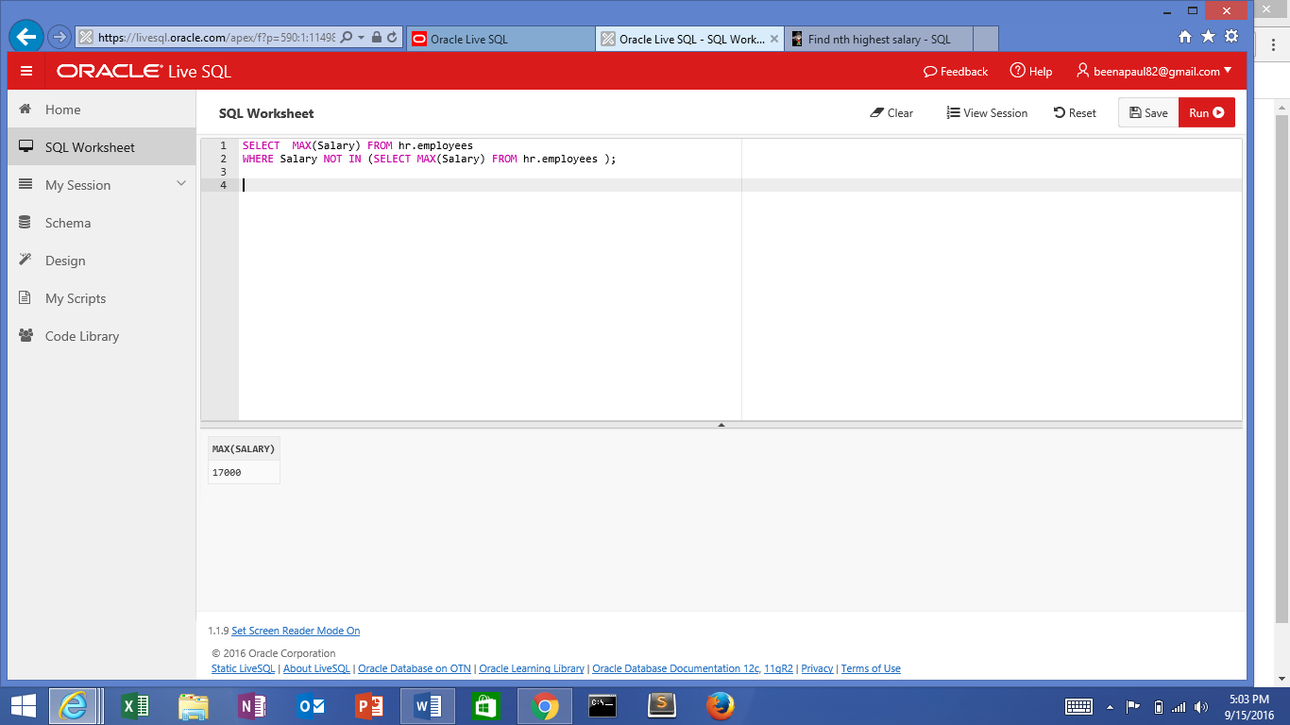

3.WAQ to find employees who earn the same salary as minimum salary in each department.